Axiom Upgrade Notes
Axiom released an upgrade that mainly involves a new logo and branding and some rearrangements of menu items in the web client only. The excel client will have the same look and functionality.
See below for the 2 changes that will affect most end-users. Please reach out to Cara Greene at cogreene@ua.edu if you have any other questions concerning the upgrade.

New version of Axiom web header:

Change #1: Reports Library moved.
Old triple-bar(“hamburger button”) used to access the reports library:
New Reports Library drop-down menu:
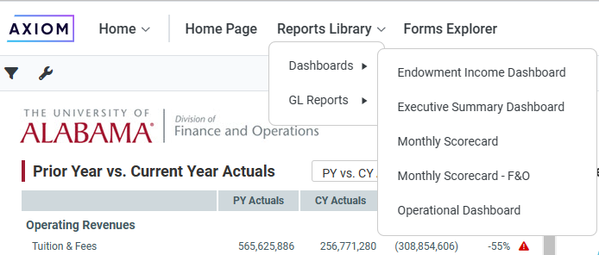

Change #2: Launch Excel Client moved
Old Rocket icon used to launch the Excel client:
New method for launching Excel client. Click the 9-dot(”waffle-icon”) to see the option to launch the excel client.
